

How to Start an Online Adult Learner Scholarship Application – FIRST TIME USERS
Follow these step-by-step instructions to start your online Adult Learner scholarship application.

Current Students: If you are renewing your Adult Learner scholarship, go to the Scholarship Renewal Information page to find the link and instructions there.

Getting Started – gather your required uploads: you do not have to have all these documents to begin the application process or set up an account, but you will need them before you can submit your application.
All first-time Adult Learner applications require:
- Your most recent transcript or grade report (which must include your name, grades for all completed semesters of study, and GPA). If you have transcripts from multiple places, please scan them into one document to upload.

- The email address to invite someone to fill out a recommendation letter on your account. Plan ahead to allow your recommender plenty of time to complete this step; it must be provided by the deadline – otherwise you will not be eligible for consideration for the scholarship. You will need the email address of your recommender to send them the link to the form. Your recommender cannot be a family member or close friend.

- Your Student Aid Report from the FAFSA, if you are eligible to complete it. This is a seven-page (or so) document and will include your Student Aid Index (SAI) as well as your family’s Adjusted Gross Income. Do not send us the FAFSA application. You can download your SAR from the FAFSA website to your desktop and then upload it to your application. https://studentaid.gov/h/apply-for-aid/fafsa If you cannot complete the FAFSA due to visa restrictions or another legal issue, please upload (as one document) an explanation of your status in place of the Student Aid Report.

Follow the steps below to access and complete the Adult Learner Long Term application
Step 1
Go to Maine Community Foundation website (http://mainecf.org) and click the orange Apply button at the top right of the screen. You can also follow online application links from the Adult Learner scholarship page, or any “Apply Now” link on the Scholarships page and related subpages.

Step 2
This link will take you to the Online Grant and Scholarship Portal.
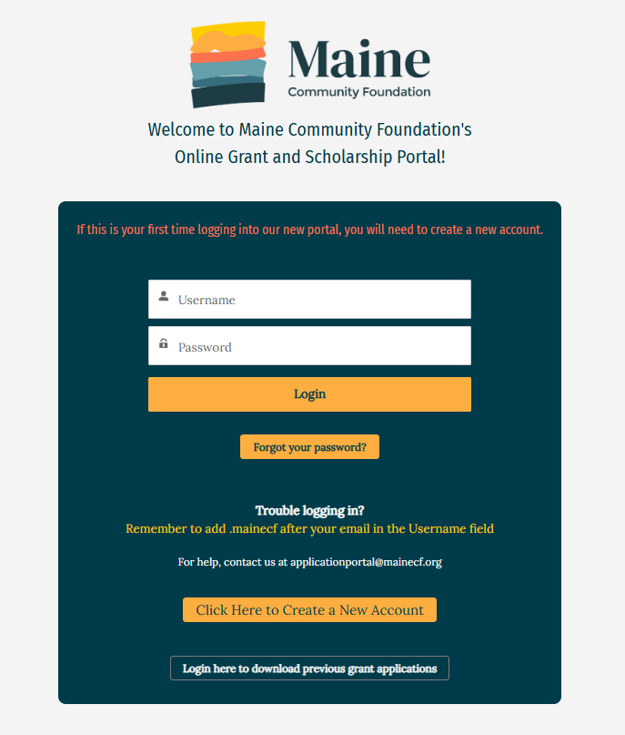

Step 3
- Click the “Create a New Account” button to create an account: If this is your first time using our online scholarship application, you need to create an account, using your name and email address. We recommend you use an email address that you check often. Do not create a new account if you opened one on this portal before. New users will receive a confirmation email; open it to confirm your account.

OR
- Log In: If you’ve previously used our online portal, type in your login information. If you forgot your password, click on the link that says “Forgot your password?” to reset it. If you used a previous version of our system, you will have to make a new account. The poral was updated September of 2025.

Step 4
You will be brought to your dashboard – there are no applications or programs currently on your page.
- Click the green “My Eligibility” tab
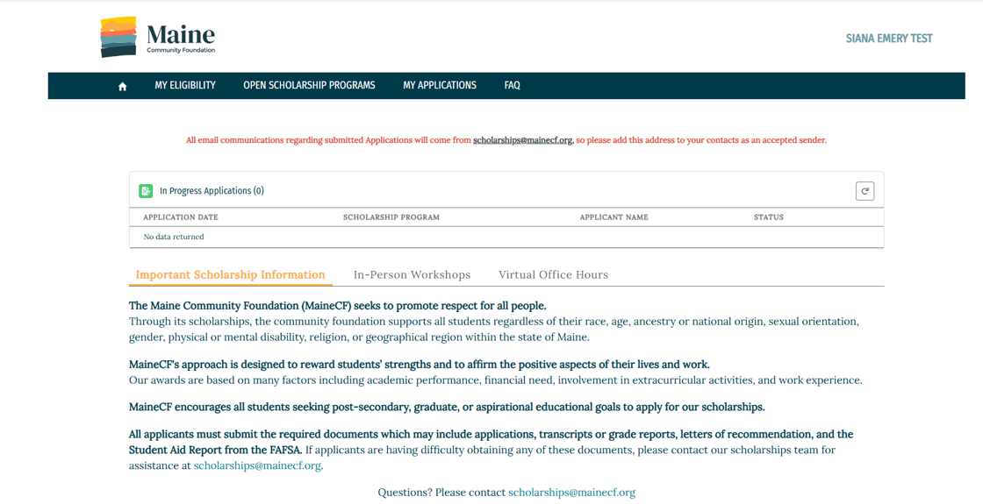
Step 5
To find the scholarships for which you’re eligible, fill out the Eligibility Profile.
- Click the button that says Update Eligibility, read the instructions, and fill out your profile. This process will provide you with a list of the scholarships that you qualify for. The Eligibility Profile can be updated at anytime.
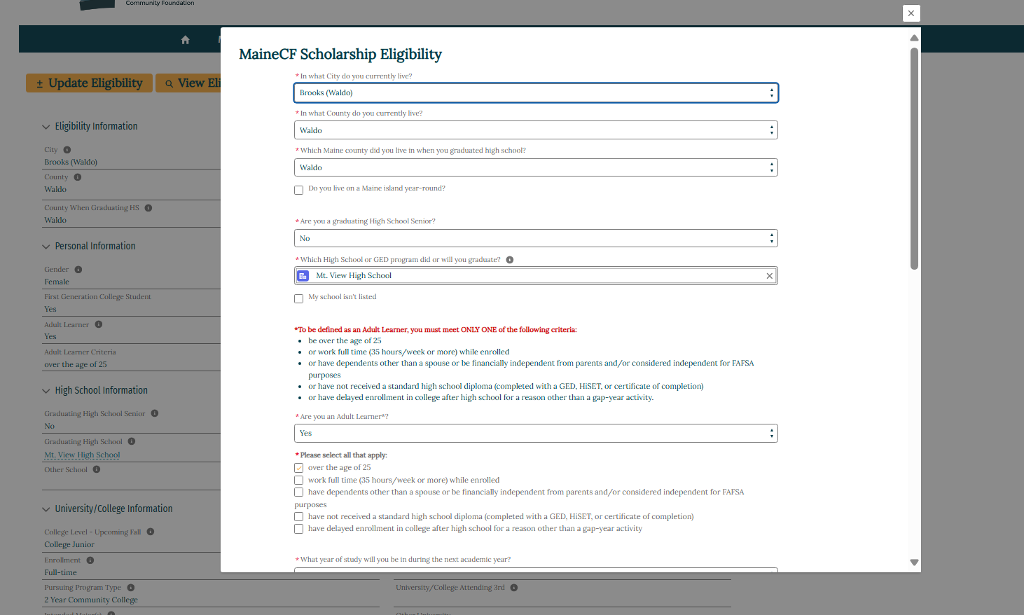
- To open the Adult Learner application, you will need to answer every question on the Eligibility Profile. Answer No to the question about renewing a scholarship, and Yes to the question about finding scholarships as a new applicant.

- If you went to high school outside Maine or the United States, or your school or GED/HiSet program is not listed in the drop-down, choose “Other” from the menu.

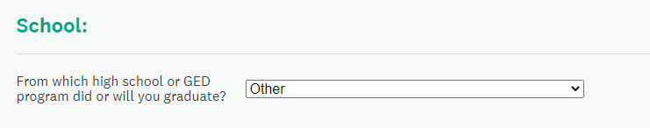
- You must answer Yes to the Adult Learner question:
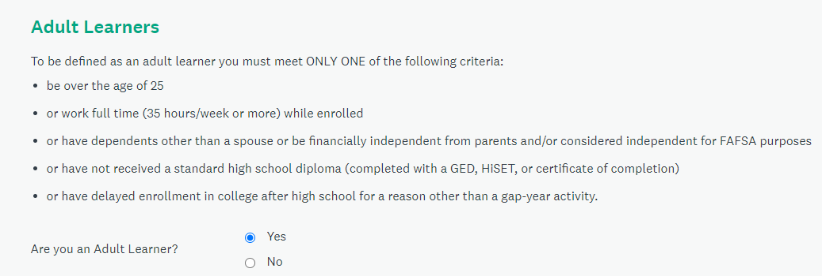

- As an adult learner, answer No to the graduating senior question, and provide answers as best you can for the rest of the questions – none of this transfers to your application, and are only for screening purposes for this application. All questions must be answered.
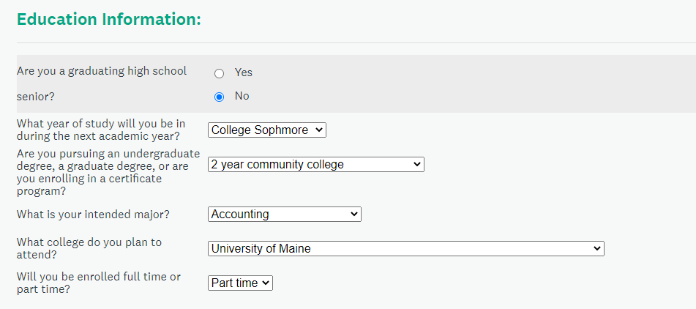

- Save your eligibility.
Step 6
- Navigate to “Open Scholarship Programs” to view your eligible scholarships. You may qualify for more than one fund.
- Scholarships in Yellow are ones that can be applied for via the online application. Scholarships in Blue are administered through a third party or have a paper application – open each box to learn more.
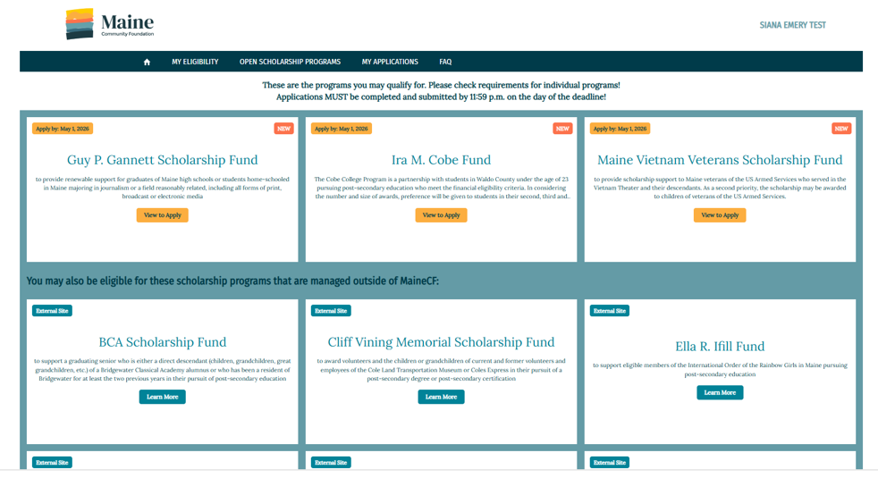
- The Adult Learner Long Term Scholarship will be in Yellow as it utilizes the online application system.
- Click “View to Apply” to learn more about the fund and access the application.
- Click the “Apply” button to open the application.

Step 7
- Begin your application. The site keeps track of your progress, so you know how you’re doing. All fields must be completed in order for the application to be submitted.
- Click each task to begin that part of your application. Tasks can be completed in any order.
- All questions must have a reply. If you don’t have an answer for a question, type N/A.
- You do not need to complete your application all in one go. However, the application does not automatically save. You must scroll to the bottom and hit “Save Application”. Applications that are in progress can be found on your dashboard under “In Progress Applications”.
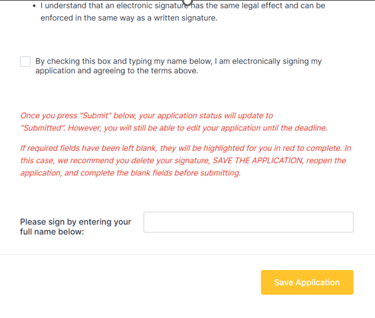
- Once you complete your application, type your virtual signature. Once you do so, the yellow “Save Application” will turn into a green “Submit Application.” An application must be submitted before the deadline. Once submitted, you cannot edit it.

- Applications will not be accepted after 11:59 pm the evening of the deadline. Once you submit an application, you cannot access it again. You will be able to view the status of your submitted application from your dashboard.


Recommendation Form
- To invite someone to provide a recommendation letter, click on the Request a Recommendation button and provider the recommender’s contact information (NOT yours). Your name will appear in the automatically generated email that is sent to your recommender.
- Click the Send Request button to send the email.
- Before submitting your application, your recommender must provide the form through the link that is sent to them, so it is a good idea to tell them the application’s deadline. Once the letter is uploaded, the check box will automatically fill.
- If you have a copy of your recommendation letter, you can also upload the file yourself.
You will hear from us about award decisions by the end of July, or December for the November 15 deadline.

