How to Start an Online Scholarship RENEWAL Application
Follow these step-by-step instructions to start your online scholarship application.

Current College Students: If you are renewing a Maine Community Foundation scholarship, go to the Scholarship Renewal Information page. You will find a list of renewable funds, required uploads and links to the application or contact information if another organization administers the application. Do not start a first-time application if you are renewing a scholarship from MaineCF. If you are renewing, but are not sure which scholarship you received, contact Liz Fickett at efickett@mainecf.org

Getting Started – gather your required uploads: you do not have to have all these documents to begin the application process or set up an account, but you will need them before you can submit your application.

All renewals require
- Your most recent transcript or grade report (which must include your name, grades for all semesters of study to December 2020, and GPA). If you have transcripts from multiple places, please scan them into one document to upload.

Some renewal applications require:
- Two letters of recommendation. You can upload these, or you may provide an email address to invite someone to upload a letter to your account. If you choose to have someone else upload your letter(s), note that your application cannot be submitted until both of your letters have been uploaded. We recommend that you start here, plan ahead and allow plenty of time to complete this step. Both of these letters must be provided by the deadline – otherwise you will not be eligible for consideration for the scholarship. You will need the email addresses of your recommenders if you would like to send them an upload invitation!

- Your college’s financial aid offer. If you are a returning college student/applicant and have not received the information for next year, you may upload the current year’s letter. If you will be attending college for the first time next year, and have not received your award letter yet, upload a placeholder document stating that you have not yet received your financial aid award information. When you receive your letter, send a copy to Maine Community Foundation, 245 Main St., Ellsworth, ME 04605.

- Your Student Aid Report (SAR) from the 2021-2022 FAFSA. This is a seven-page (or so) document and will include your EFC as well as your family’s Adjusted Gross Income. Do not send us the FAFSA application. You can download your SAR from the FAFSA website to your desktop, and then upload it to your application. https://studentaid.gov/h/apply-for-aid/fafsa

Some applications require other supporting documents, which are specified on the application itself.

Step 1
Go to Maine Community Foundation website (http://mainecf.org) and click the orange Apply button at the top right of the screen, or the follow online application links from our scholarship Renewals pages.
Step 2
On the left side you will see Online Scholarship Applications. Click the Apply Here button to access our online scholarship application system.
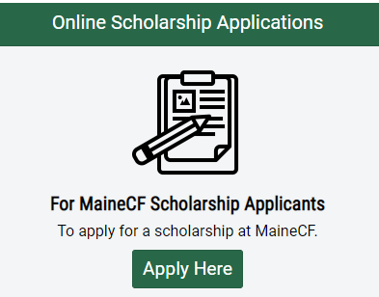
Step 3
In the top right corner you will see the options to Log In or Register
• Log In- If you’ve previously used our online scholarship application system, type in your login information. If you forgot your password, click on the link that says “Forgot your password?” to reset it.
• Register- If this is your first time submitting an online scholarship application, you will need to create an account, using your name and email address. We recommend you do not use your high school email address because it doesn’t follow you after graduation. If you’ve used our online application before, then use the same sign in credentials as you’ve used before. If you’re unsure of your user name/email, contact Liz Fickett at lfickett@mainecf.org and she’ll look it up for you. Do not create a new account.
New users will receive a confirmation email; open it and click the green Confirm email address button in that email to be brought back to the application site. Click the green Continue button
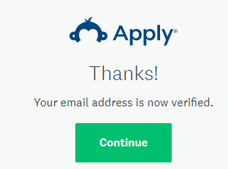

Step 4
You will be brought to your Program Page – there are no applications or programs currently on your page, so click the green View Programs button. You will be prompted to update your eligibility profile. You must do this to open the drop-down renewal list in your portal.
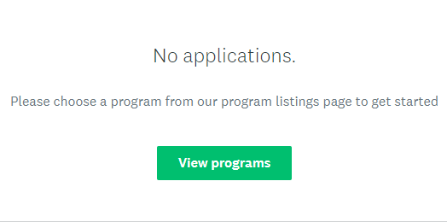

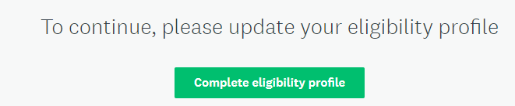

Step 5
To find the scholarships for which you’re eligible, you’ll need to fill out the Eligibility Profile. Click the green button, read the instructions, and answer Yes to the renewal question and pick your scholarship from the drop-down list. This process will help to narrow down the scholarships in our database to those that you qualify for, so answer the questions as correctly and completely as possible!
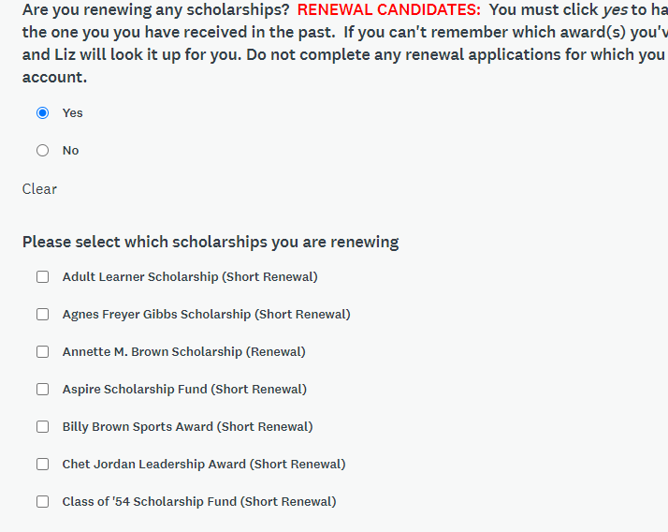
When you’re finished, click Save My Profile to be brought your renewal application(s).
Step 6
You’ll be brought to your home page, listing all the scholarships for which you’re eligible to apply. Click the green More button to read about the scholarship and access the application. Pay close attention to all renewal instructions- you cannot apply for a scholarship you have not received in the past.
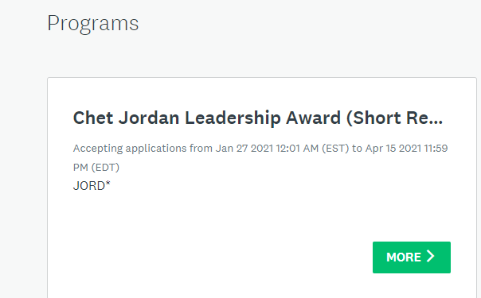

Step 7
Read the scholarship description to find out what kind of candidate the committee is looking for, and then click the green Apply button.
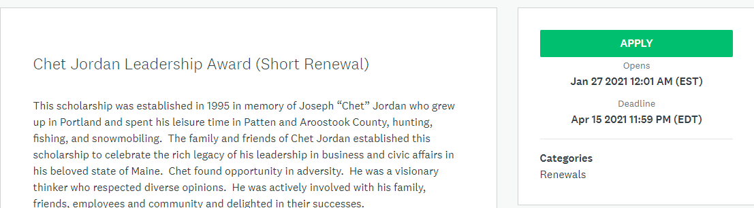

Step 8
Begin your application. The site keeps track of your progress, so you know how you’re doing. For our application, the only thing you’ll need to do more than one time is the essay. The other pieces transfer to multiple applications (if there are more than one for which you’re eligible)

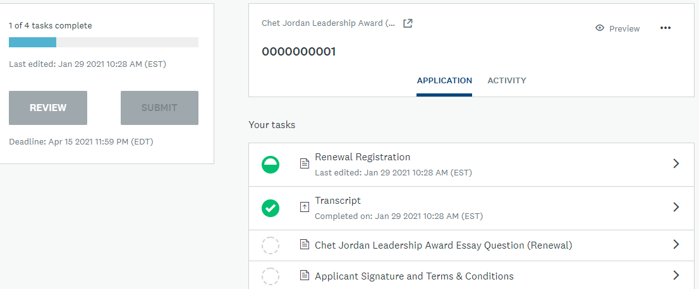

- Overview: Application status. Most applications have between 5-7 tasks to complete.
- Submit button: This is the final submit button. Once all tasks have been completed, this button will turn green. An application must be submitted before the deadline. Once submitted, you cannot edit it.
- Preview: Preview your entire application
- Options: Download or delete your application
- Tasks: Shows the status (symbols below) of each task – all must be complete before submitting.
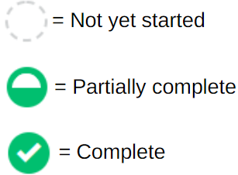
You can do the tasks in any order that you want, and you can also start, save, and come back another time to finish. Just remember, our deadlines are firm, we do not make extensions for any reason, and applications must be submitted by 11:59 PM on the deadline date.

