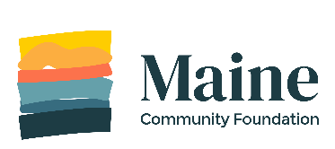
Grant Application Document Cover Form

You have chosen to attach additional information to your MaineCF grant application.
Please fill out this form and send it with your documents to:
Applications
Maine Community Foundation
245 Main St.
Ellsworth, ME 04605

ORGANIZATION: _________________________________________

CONTACT NAME: _________________________________________

CONTACT PHONE or EMAIL: _________________________________

GRANT PROGRAM: ________________________________________

DOCUMENTS:
 | Condition | Required Documents
 | If you are applying for a project that includes working with a school | A letter of agreement from a school representative that explains the school’s level of involvement
 | If you are applying for a project that includes working with a tribe | A letter of agreement from a tribal representative (Aroostook Band of Micmacs, Houlton Band of Maliseet Indians, Passamaquoddy Tribe at Indian Township, Passamaquoddy Tribe at Sipayik, Penobscot Nation) that explains the tribe's level of involvement
 | If you are applying for a project that includes a partnership with another organization (other than a school) | A letter of agreement from the partner organization that explains their level of involvement.
 | If your organization is a public school or school district | A letter from the principal or superintendent agreeing to accept MaineCF grant funds for your project
 | A municipal library | A letter from the Town or City Manager confirming your organization's municipal status (Note that libraries with separate 501(c)(3) tax-exempt public charity status do not need this letter.)
 | A town/city or government/municipal agency | A letter from the head of agency agreeing to accept MaineCF grant funds for your project

Please DO NOT INCLUDE
- Audited financials or 990 forms
- 501(c)(3) letters of determination
- Annual Reports
- General letters of support

