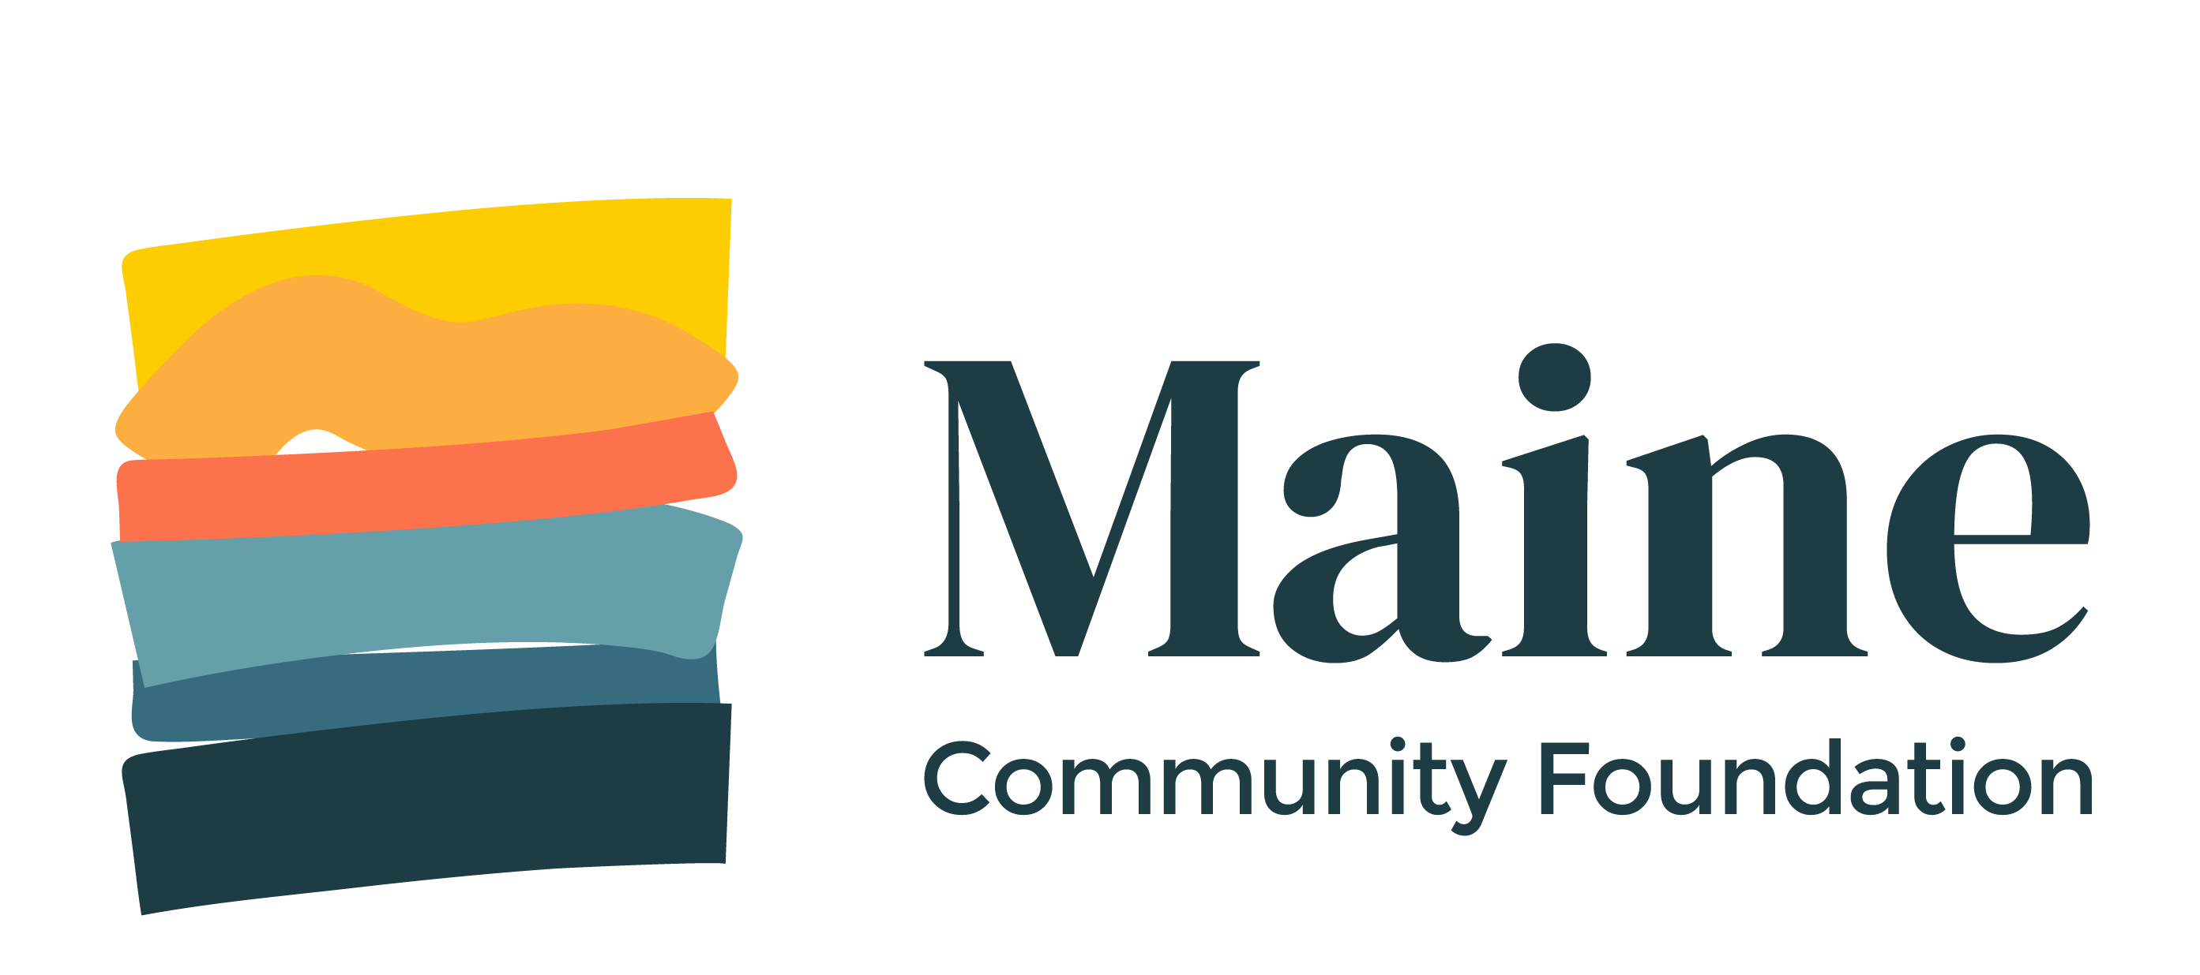
Maine Community Foundation
DAF Grant Report

Please use this form if you have received a grant from a donor-advised fund (DAF) at the Maine Community Foundation and have been asked to submit a grant report. Grant reports help us better understand the impact of our grantmaking, learn about your organization, and find out about issues across the state.
NOTE: If you need to request an extension or discuss changing the purpose for which you received your grant, please contact us at grants@mainecf.org.
Grantee Organization:
Contact Name: |  | Contact Phone:
Contact Email:
Grant Date: | Grant Amount:
One-sentence description:

At this time, the activity you received funding for is (check one): | ☐ Complete  ☐ In Progress. Estimated Completion:  ☐ Not yet begun  ☐ Ongoing

How did you use the grant funding you received from MaineCF?

What is one thing (big or small or anywhere in between) that you were able to accomplish as a result of this funding?

What have you learned from the work or project funded by this grant? Please share what worked well and what didn’t and why.

What unmet or upcoming needs do you anticipate for your organization or community?

Any additional comments/notes:

Report Submitted By:

Date:

Thank you!

Please email this completed form to grants@mainecf.org or mail to:
Maine Community Foundation
50 Monument Square, 6th Floor
Portland, ME 04101

