How to Start your Online RENEWAL application for the
Adult Learner Scholarship

Follow these step-by-step instructions to complete your online scholarship application.

Getting Started
Your Adult Learner renewal application requires
- Your most recent transcript, unofficial transcript, or grade report (which must include your name, grades for all semesters of study to December 2020, and GPA). If you have transcripts from multiple places, please scan them into one document to upload.

you do not have to have this to begin the application process or set up an account, but you will need it before you can submit your application.

Step 1
Go to Maine Community Foundation website (http://mainecf.org)
- Click the orange Apply button at the top right of the screen, or follow the online application links from our scholarship Renewals page
Step 2
On the left side you will see Online Scholarship Applications
- Click the Apply Here button to access our online scholarship application system.

Step 3
Log in or register
In the top right corner, you will see the options to Log In or Register
• Log In- If you’ve previously used our online scholarship application system, type in your login information. If you forgot your password, click on the link that says, “Forgot your password?” to reset it.
OR
• Register- If this is your first time submitting an online scholarship application, you will need to create an account, using your name and email address. We recommend you use an email address that you check often. If you’ve used our online application before, then use the same sign in credentials as you’ve used before. If you’re unsure of your user name/email, contact Liz Fickett at lfickett@mainecf.org and she’ll look it up for you. Do not create a new account.
- New users will receive a confirmation email; open it and click the green Confirm email address button in that email to be brought back to the application site.
- Click the green Continue button
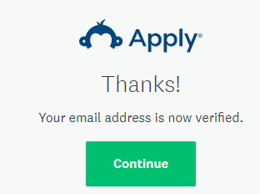

Step 4
You will be brought to your Program Page – there are no applications or programs currently on your page
- Click the green View Programs button to be brought to the next step.

Step 5
To open the Adult Learner Scholarship renewal application, complete the Eligibility Profile.
- Click the green button, read the instructions, and fill out your profile.
- Answer Yes to the renewal question and pick the Adult Leaner Scholarship (Short Renewal) from the drop-down list. Then answer the rest of the questions – all must be answered in order to access your application.
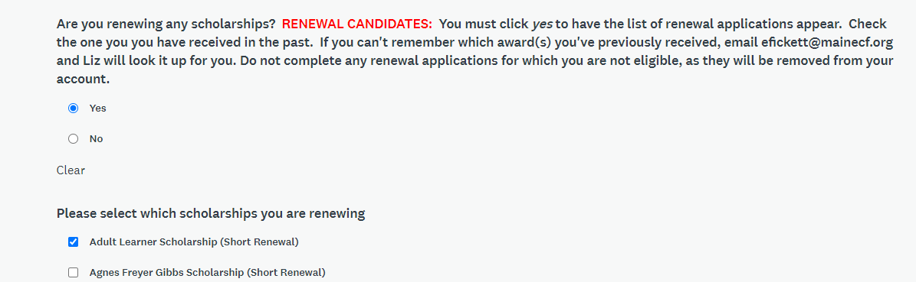
- If you went to a high school outside Maine or the United States, or your school or GED/HiSet program is not listed in the drop-down, choose “Other” from the menu.

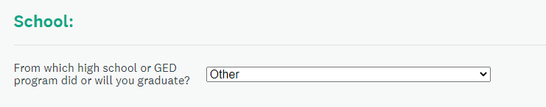

- When you’re finished, click Save My Profile to be brought to the Adult Learner renewal application.

Step 6
You’ll be brought back to your home page, listing the Adult Learner Scholarship (Short Renewal)
- Click the green More button to read about the scholarship and access the application.
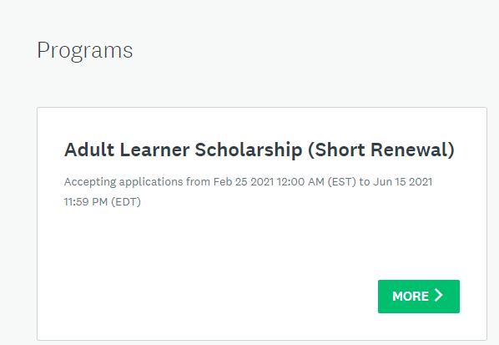
Step 7
Read the scholarship description
- Click the green Apply button to open the application.
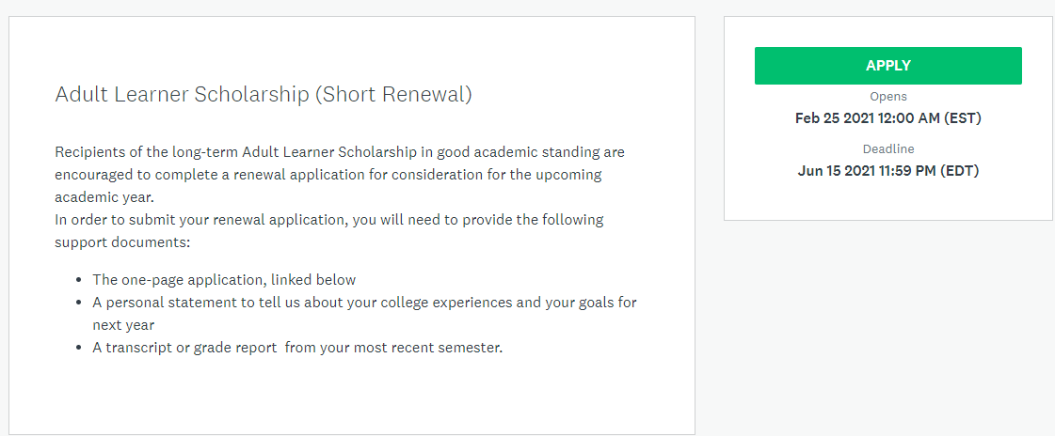

Step 8
Begin your application. The site keeps track of your progress, so you know how you’re doing.
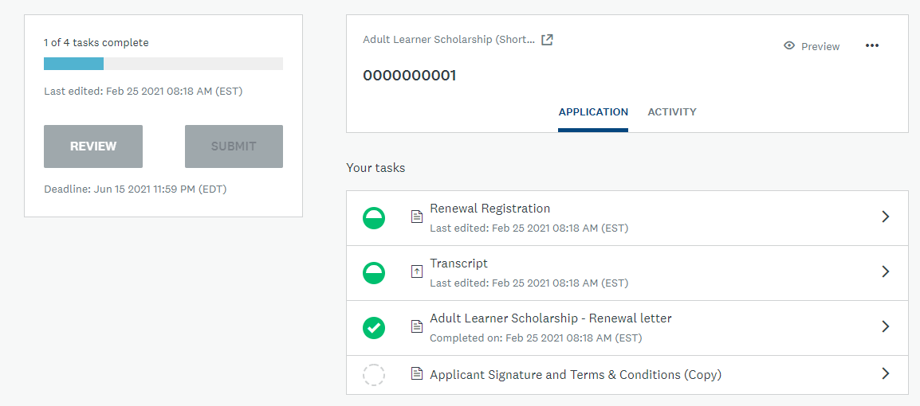

- Overview: Application status. Most applications have between 4-8 tasks to complete.
- Submit button: This is the final submit button. Once all tasks have been completed, this button will turn green. An application must be submitted before the deadline. Once submitted, you cannot edit it.
- Preview: Preview your entire application
- Options: Download or delete your application
- Your Tasks: Shows the status (symbols below) of each task – all must be complete before submitting.
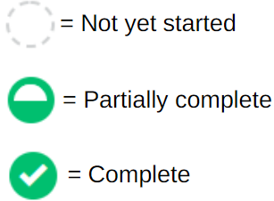
- You can do the tasks in any order you choose, and you can also start, save, and come back another time to finish. Just remember, our deadlines are firm, we do not make extensions for any reason, and applications must be submitted by 11:59 PM on the deadline date. (June 15 and November 15)

- When you complete a task, be sure to mark it as complete by clicking on the green button at the bottom

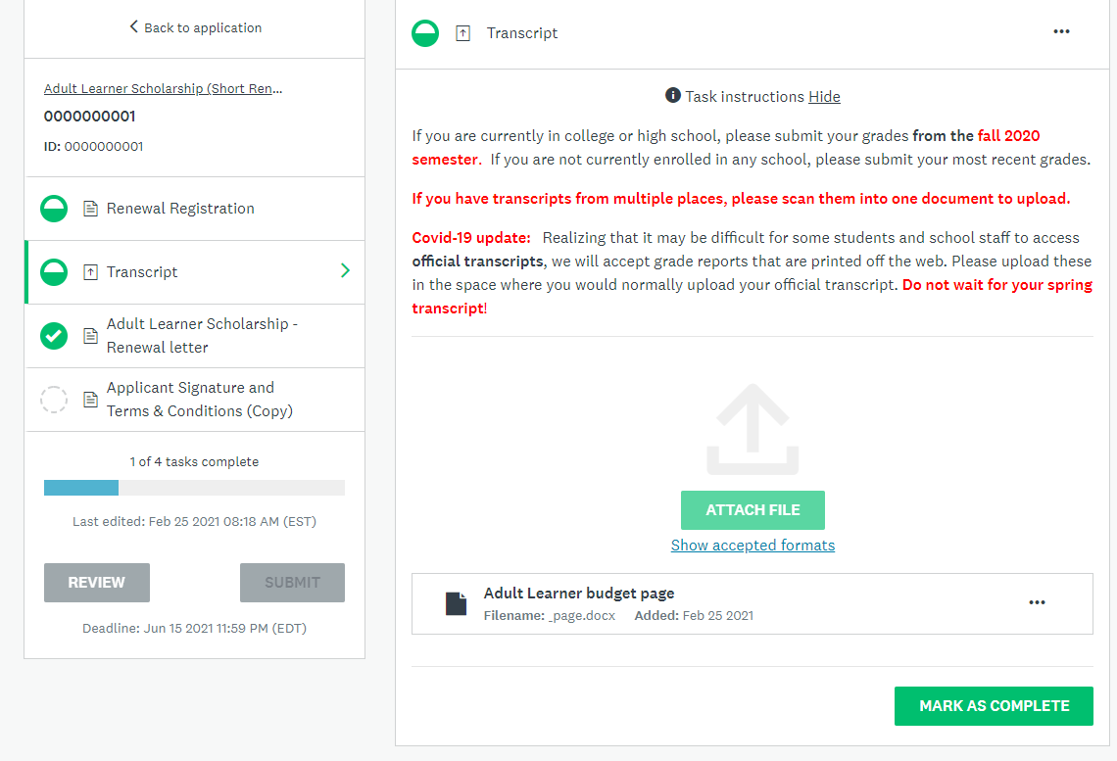

Step 9
Your last task is supplying your electronic signature – this must be done before submitting your application
- Click on the green arrow beside Applicant Signature and Terms & Conditions
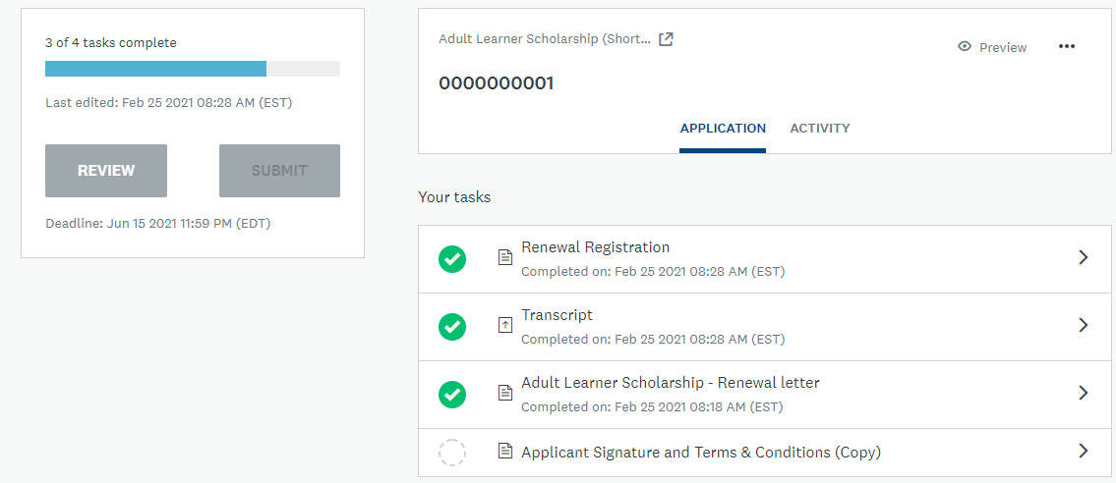

- Check all the boxes, type in your name and the date, click Mark As Complete.
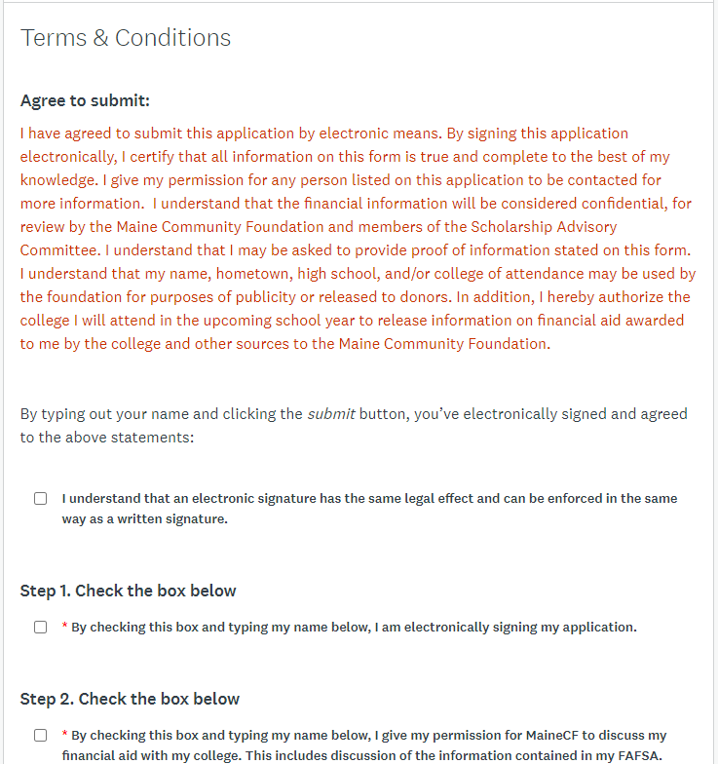
Step 10
When all of your tasks show as complete (be sure you’ve clicked the Show as Complete buttons for each task), submit your application
- Click the green Submit button
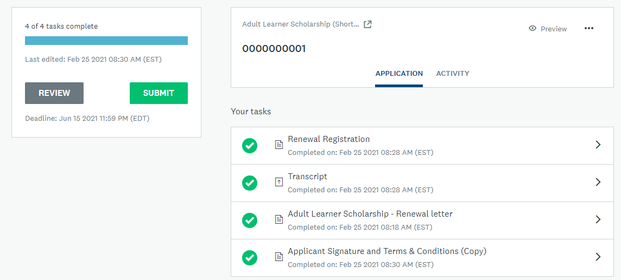

- You will be given the option to review your application – if you have not done so yet, it’s important that you take this final opportunity to look over your application before submitting. Once submitted, you cannot make any changes to your application.
- When you’re sure it’s done to your satisfaction, click the green Submit button.

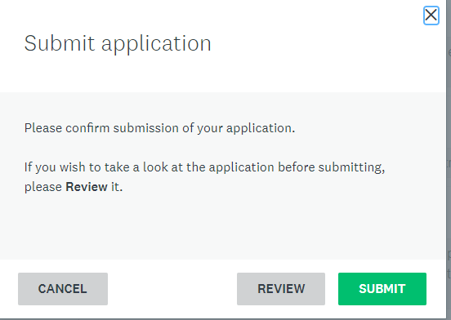

- You’ll receive a confirmation on the screen:

- Click the Go to My Applications button to return to your homepage, where you’ll see that your application has been successfully submitted

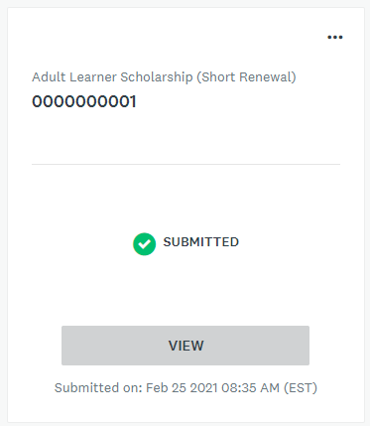

- You also will receive an email confirmation that your application was submitted
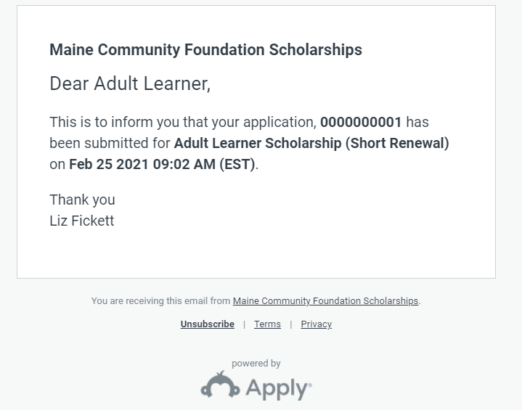

Please note: you will hear from us about award decisions by the end of July, (or December for the November 15 deadline).

If you run into any difficulties, or have any questions, please email me at lfickett@mainecf.org

