How to Start an Online Adult Learner Scholarship Application – FIRST TIME USERS
Follow these step by step instructions to start your online Adult Learner scholarship application.

Current College Students: If you are renewing your Adult Learner scholarship, go to the Scholarship Renewal Information page to find the link and instructions there.

Getting Started – gather your required uploads: you do not have to have all these documents to begin the application process or set up an account, but you will need them before you can submit your application.
All first-time Adult Learner applications require:
- Your most recent transcript, unofficial transcript, or grade report (which must include your name, grades for all semesters of study to December 2020, and GPA). If you have transcripts from multiple places, please scan them into one document to upload.

- The email address to invite someone to fill out a recommendation form on your account. Plan ahead and allow your recommender plenty of time to complete this step; it must be provided by the deadline – otherwise you will not be eligible for consideration for the scholarship. You will need the email address of your recommender to send them the link to the form. Your recommender cannot be a family member or close friend.

- Your Student Aid Report (SAR) from the 2021-2022 FAFSA, if you are eligible to complete it. This is a seven-page (or so) document and will include your EFC as well as your family’s Adjusted Gross Income. Do not send us the FAFSA application. You can download your SAR from the FAFSA website to your desktop, and then upload it to your application. https://studentaid.gov/h/apply-for-aid/fafsa If you are not eligible to file the FAFSA, upload a blank piece of paper, or an explanation of why you are not uploading the Student Aid report to your application.

Follow the steps below to access and complete the Adult Learner Long Term application

Step 1
Go to Maine Community Foundation website (http://mainecf.org) and click the orange Apply button at the top right of the screen. You can also follow online application links from the Adult Learner scholarship page.
Step 2
On the left side you will see Online Scholarship Applications.
- Click the Apply Here button to access our online scholarship application system.
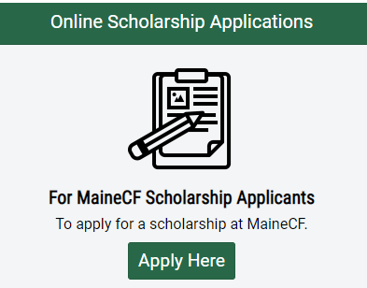

Step 3
You will be brought to the home page of our online application system.
In the top right corner you will see the options to Log In or Register
• Log In- If you’ve previously used our online scholarship application system, type in your login information. If you forgot your password, click on the link that says “Forgot your password?” to reset it.
OR
• Register- If this is your first time using our online scholarship application, you need to create an account, using your name and email address. We recommend you use an email address that you check often. If you’ve used our online application before, then use the same sign-in credentials as you’ve used before. If you’re unsure of your user name/email, contact Liz Fickett at lfickett@mainecf.org and she’ll look it up for you. Do not create a new account if you opened one before.
New users will receive a confirmation email; open it and click the green Confirm email address button in that email to be brought back to the application site.
- Click the green Continue button
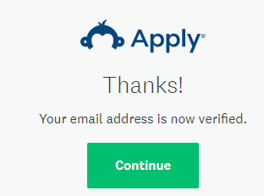

Step 4
You will be brought to your Program Page – there are no applications or programs currently on your page
- Click the green View Programs button.

Step 5
To find the scholarships for which you’re eligible, fill out the Eligibility Profile.
- Click the green button, read the instructions, and fill out your profile. This process will provide you with the scholarships that you qualify for, so answer all of the questions.
- To open the Adult Learner application, you will need to answer every question on the Eligibility Profile. Answer No to the first questions about renewing a scholarship, and Yes to the question about finding scholarships as a new applicant. Click the green Next button at the bottom of the page to be brought to the rest of the questions on the Profile.

- If you went to high school outside Maine or the United States, or your school or GED/HiSet program is not listed in the drop-down, choose “Other” from the menu.

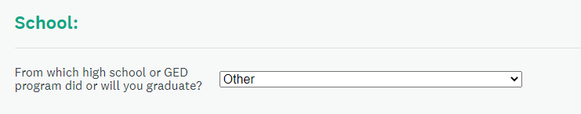
- You must answer Yes to the Adult Learner question:
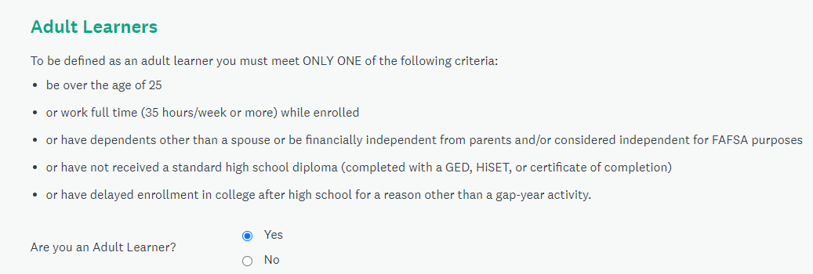

- As an adult learner, answer No to the graduating senior question, and provide answers as best you can for the rest of the questions – none of these transfer to your application, and are only for screening purposes for this application. All questions must be answered.
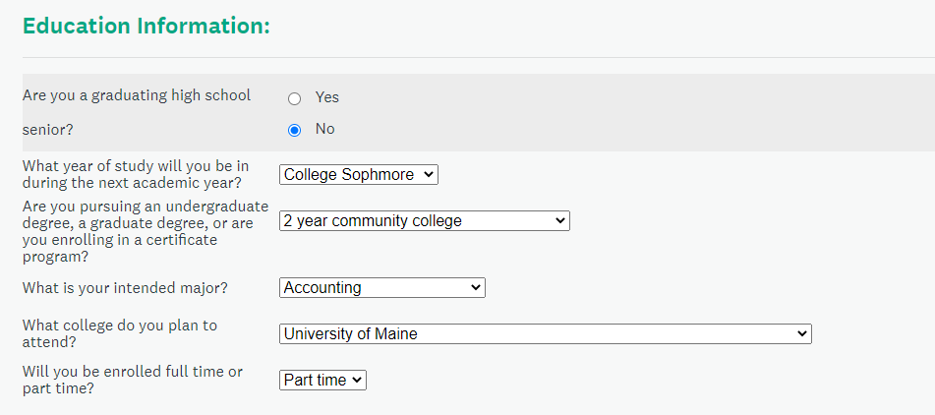

- Answer each question
- Click the green Save My Profile button.

Step 6
You’ll be brought to your home page.
- Activate the Adult Learner application to your account by clicking the green View Programs link.
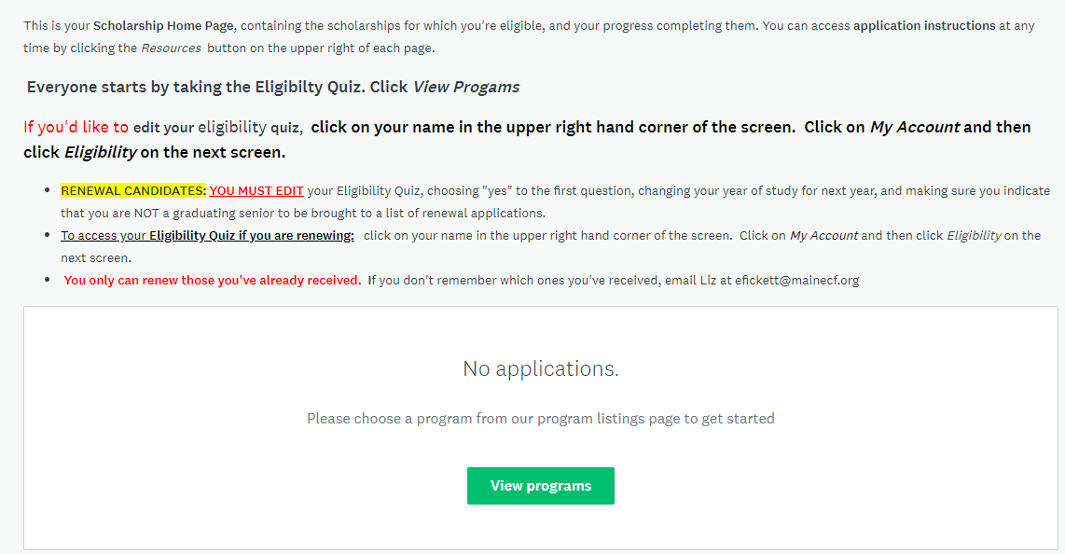

- Click the green More button to read about the scholarship and access the application.
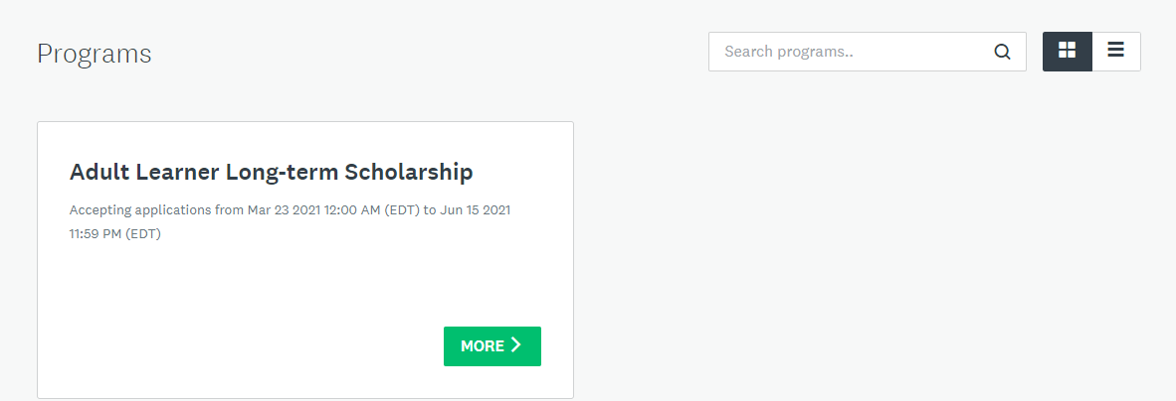

Step 7
Read the scholarship description
- Click the green Apply button.
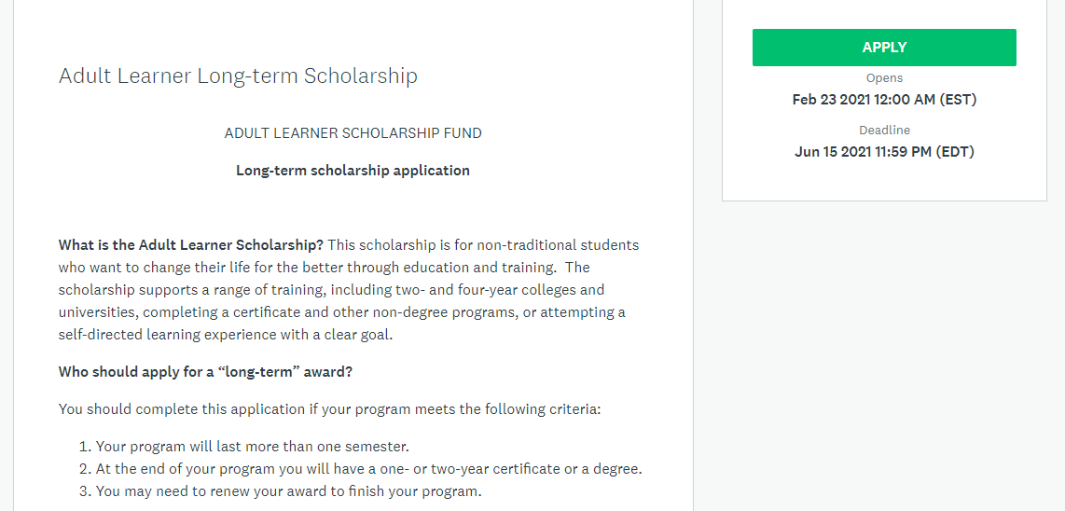

Step 8
Begin your application. The site keeps track of your progress, so you know how you’re doing.
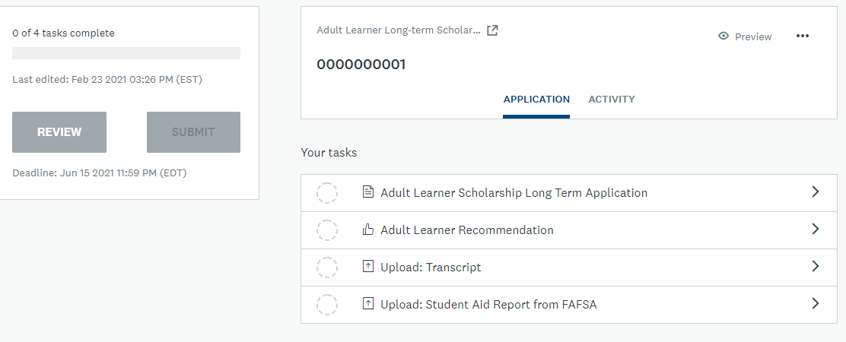
- Overview: Application status. Most applications have between 5-7 tasks to complete.
- Submit button: This is the final submit button. Once all tasks have been completed, this button will turn green. An application must be submitted before the deadline. Once submitted, you cannot edit it.
- Preview: Preview your entire application
- Options: Download or delete your application
- Your Tasks: Shows the status (symbols below) of each task – all must be complete before submitting.
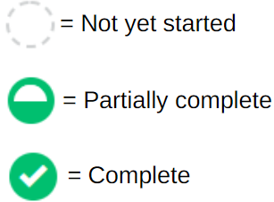
Click the green arrow beside each task to begin that part of your application.
- Do the tasks in any order that you want; you can start, save, and come back another time to finish.
- Our deadlines are firm, we do not make extensions for any reason, and applications must be submitted by 11:59 PM on the deadline date.
- All questions must have a reply. If you don’t have an answer for a question, type NA in that field.
- When you finish a task, be sure to Mark As Complete
- As you move through the application, your progress will be updated.

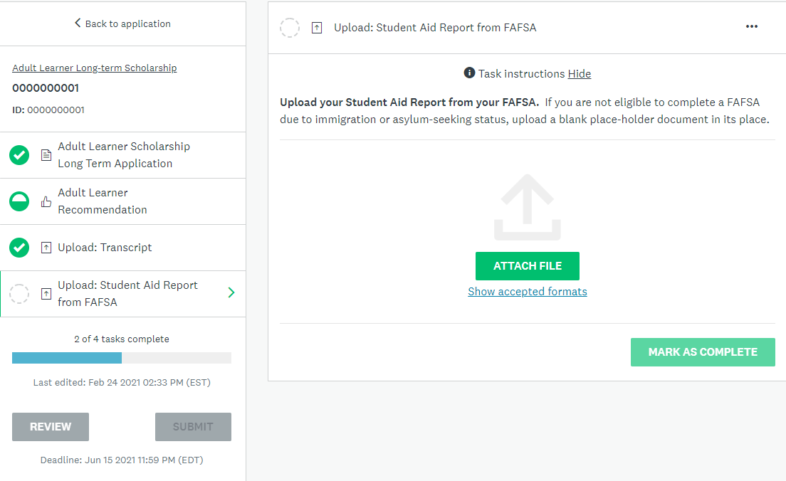

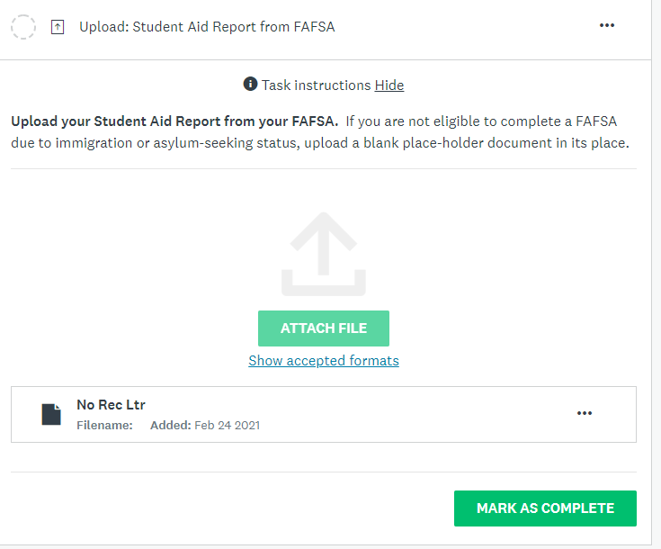

Recommendation Form
- To invite someone to provide a recommendation form for you, you’ll need their email address.
- Click on the green Request a Recommendation button and provide the recommender’s information (NOT yours). Your name will appear in the automatically generated email that is sent to your recommender.

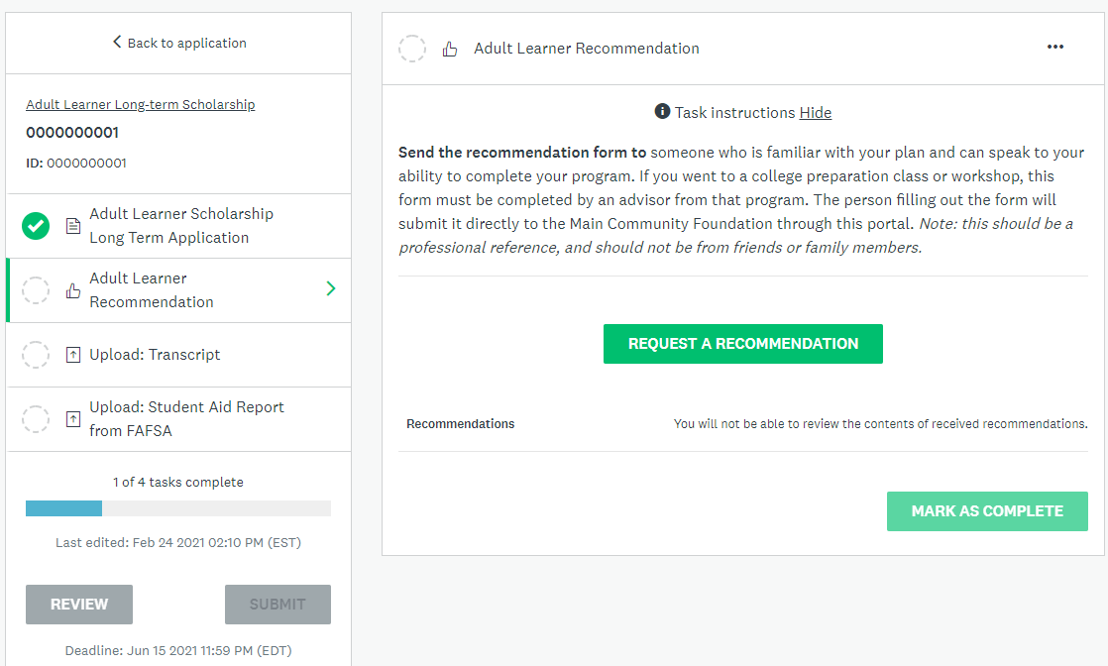

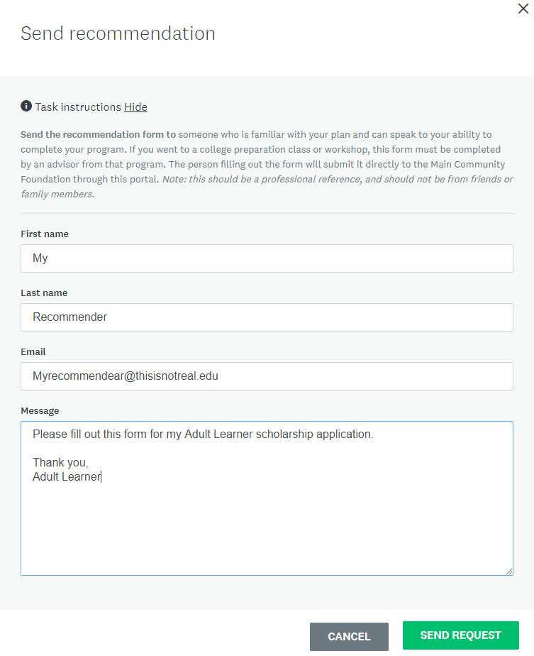

- Click the green Send Request button to send the email.
- Before submitting your application, your recommender must provide the form through the link that is sent to them, so it is a good idea to tell them the application’s deadline

Step 9
- Your last task is supplying your electronic signature – this has to be done before submitting your application.
- Check all the boxes, type in your name and the date, click Mark As Complete.

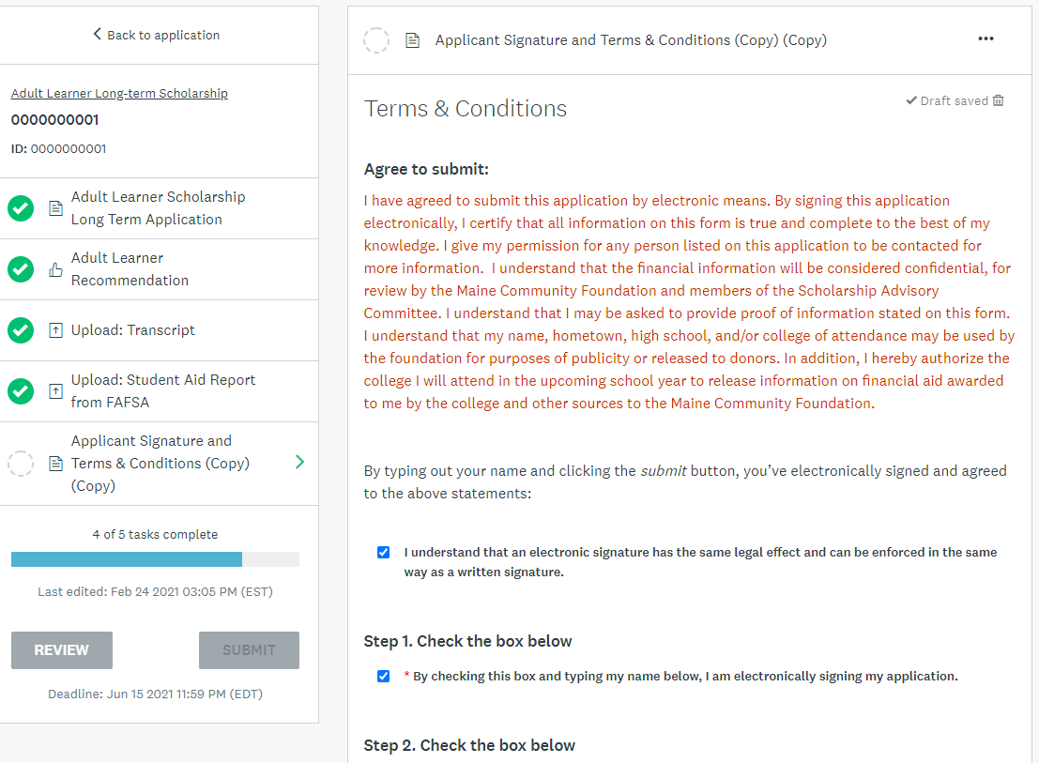

Step 10
When all of your tasks are complete, showing green marks, (be sure you’ve clicked the Show as Complete buttons for each task), submit your application
- Click the green Submit button:
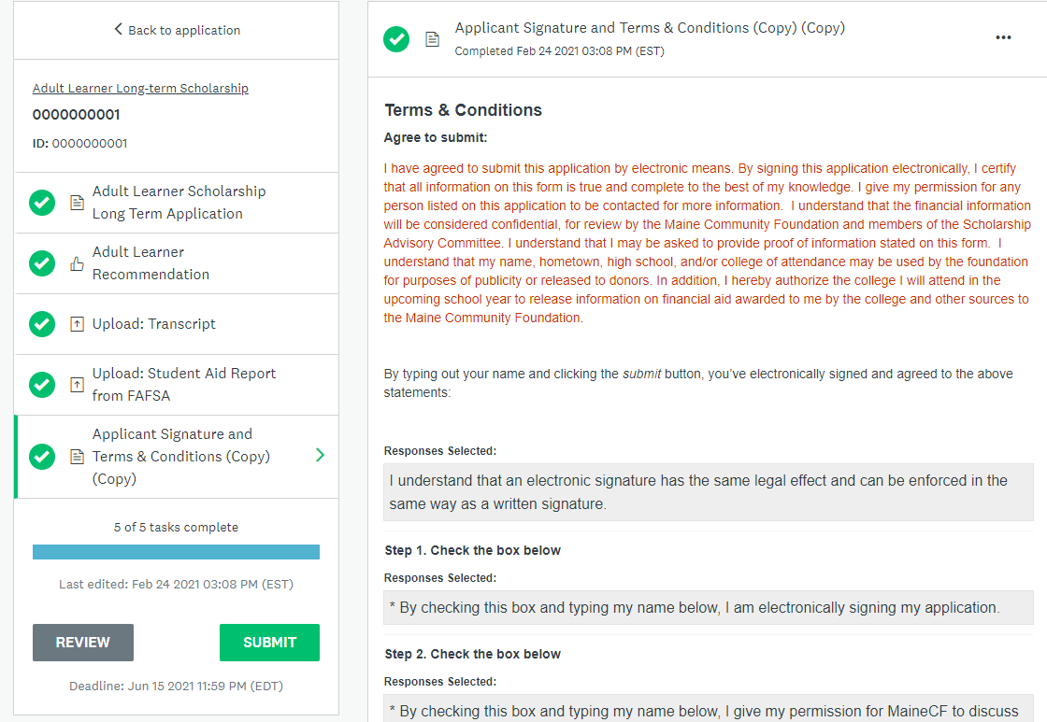

- You will be given the option to review your application – if you have not done so yet, it’s important that you take this final opportunity to look over your application before submitting. Once submitted, you cannot make any changes to your application.
- When you’re sure it’s done to your satisfaction, click the green Submit button.
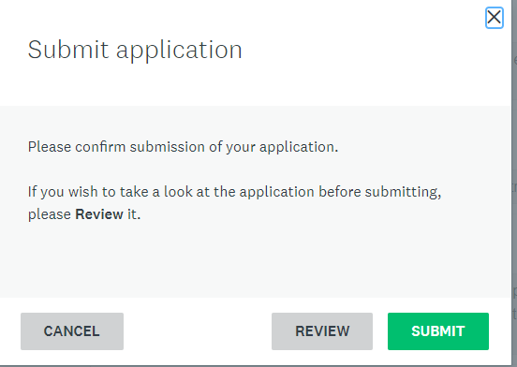

You’ll receive a confirmation:

- Click the Go to My Applications button to return to your homepage, where you’ll see that your application has been successfully submitted

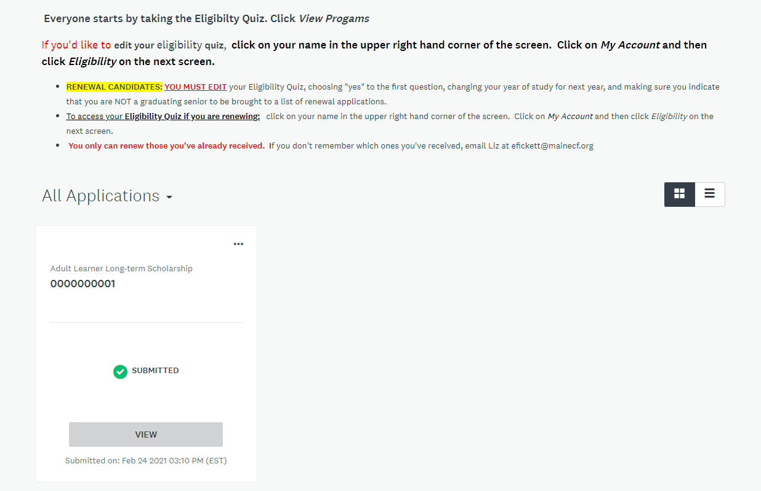
- You also will receive an email confirmation that your application has been submitted.

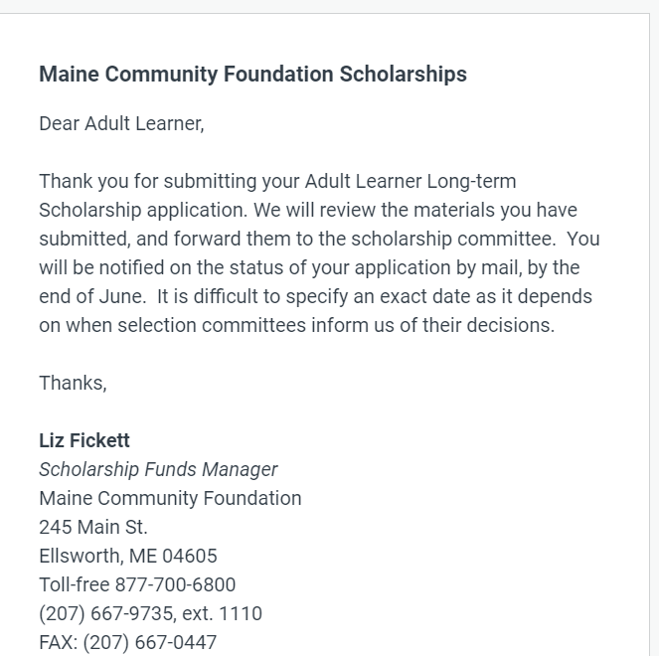

Please note: you will hear from us about award decisions by the end of July, (or December for the November 15 deadline).

If you run into any difficulties, or have any questions, please email me at lfickett@mainecf.org

